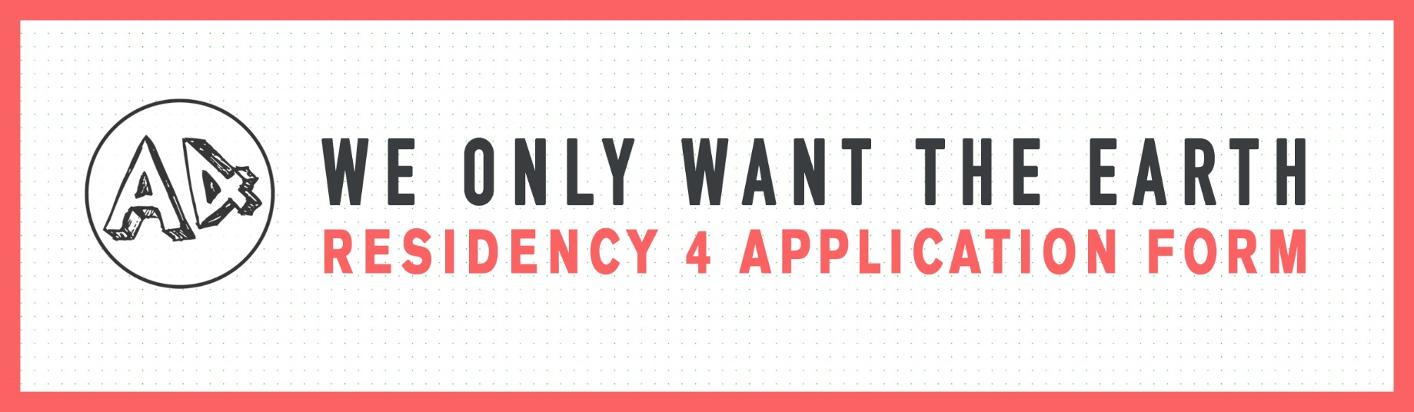

PLEASE NOTE APPLICATIONS WILL BE ACCEPTED VIA OUR ONLINE FORM ONLY.
THIS DOCUMENT IS FOR OFFLINE EDITING ONLY.
Please use this document to prepare and edit your answers prior to submitting your form online.
The application form can be found via this link: https://a4sounds.org/we-only-want-the-earth-residency-4-application-form/

Section 1: About You
Short Bio:
Please tell us about yourself. Here you can include information about who you are and your artistic experience. Examples could be: If you have studied art and what you studied, or exhibitions, performances or art events you have taken part in, organised or curated. Please keep in mind what you are proposing to do for the residency; it would be good to talk about aspects of your experience, or achievements that are relevant to your proposed idea. This will allow the panel to assess your potential and ability to develop the body of work you propose.
Maximum 1800 characters (approx. 300 words).

Please tell us about your practice:
Describe the work that you make, themes you explore, your main interests, and your goals and ambitions as an artist.
Maximum 1800 characters (approx. 300 words).
Section 2: Your Proposal
Please tell us about the work you want to make during the residency:
What topic(s) do you want to explore? What do you want to do and how will you do it? How does this relate to the theme of the We Only Want the Earth programme? This is the most important question on the application form. Please take some time to consider your answer. We recommend you read about our programme here: https://a4sounds.org/we-only-want-the-earth/. You can give an overview of how you intend to make this work here, and below in the schedule section you can give us a more detailed description of your proposed activities.
Be ambitious with your ideas. Be critical, and/or playful. We have a wonderful team to support the residency, so this is an opportunity to take some artistic risks and advance your practice. If you have questions you can email us via residency@a4sounds.org.
Maximum 3200 characters (approx. 500 words)

Please describe how your proposed idea may work if we are affected by changing restrictions due to COVID-19:
During the timeframe of this residency, we may be affected by changing restrictions due to the COVID-19 pandemic. The residency team will work with you from the beginning to ensure we build in alternative & digital options in case of ongoing restrictions and possible gallery closures. However, we would encourage you to think about how your work maybe impacted and how you could build in some flexibility to your proposal. For example: If you are proposing collaborative work, how would you cater for this? Can your proposal work online and offline? Can your work be filmed? And so on.
Maximum 1800 characters (approx 300 words).

Proposed Residency Schedule
Please use this section to describe how you will carry out the work you have proposed above. This may include describing your activities each month, your research period, experimentation period, rehearsal times, production period, who you will collaborate with and when and how, and so on. This section is a tool to help you plan and understand your proposal better. Mapping your time will help you understand the full scope and potential workload of your ideas, which will help you edit your final application.
This information will help the panel understand your process and way of working better, as well as assess the feasibility of your proposed idea. We understand that as your ideas evolve your work may take different directions and change, so we will consider this section a working document that you can update throughout your residency. We also understand this may be the first time you have worked this way, and/or there may be some unknown elements in your proposal. If so, you can state them, or help you would need in this section.

PROPOSED WORK / ACTIVITIES
MONTH 1: NOV/DEC 2021
MONTH 2: DEC/JAN 2022
MONTH 3: JAN/FEB 2022
EXHIBITION / OUTCOMES
MONTH 4: FEB/MAR 2022
17th Feb – 6th Mar 2022
Exhibition / Outcomes Duration

Why do you want this award?
Please tell us why the residency interests you. How would the residency help you to develop as an artist? This is the place to put any other information you consider relevant.
Maximum 1800 characters (approx 300 words).

Section 3: Other Commitments
This residency carries a significant workload for the successful applicant and will require a full-time commitment. However, we do understand you may have additional work commitments.
Please let us know of other commitments you will have during the period of this residency and how you will balance them with your studio time:
Please specify any commitments you have to other employment, residencies, exhibitions/performances, conferences, research/education during the period of the residency (15th November 2021 – 9th March 2022). Please describe how you intend on balancing these commitments with your studio time.

Section 4: Examples of previous work
Please provide up to 5 examples of your previous work.
For each example, please provide a description of the work and EITHER (a) provide a link to the work OR (b) upload an image, video, or audio file.
This section is especially important. It allows the panel to judge your ability to successfully create the proposed work. Try to choose examples of work that are relevant to your proposal. Think about how the examples could demonstrate the ambition, themes, medium or skills required in your proposed idea. The majority of these examples should include examples of your previous artworks, but you may also include non-art related examples which provide evidence of skills and experience necessary for your proposal. Please note there is max file size of 10MB per example. If you are submitting large audio or video files it may be easier for you to upload to youtube, vimeo or soundcloud and share the link.

Example 1
1a. Title:
1b. Please give a short description of the artwork:
Example 2
2a. Title:
2b. Please give a short description of the artwork:

Example 3
3a. Title:
3b. Please give a short description of the artwork:

Example 4
4a. Title:
4b. Please give a short description of the artwork:

Example 5
5a. Title:
5b. Please give a short description of the artwork:

